**Top 5 Best Microphones Available: in 2021**

For your best experience

We all are familiar with what a microphone is. Still, if we want to define it in a single line; a microphone is a digital device for converting sound into electric energy which is used in radio broadcasting, recording, and many other areas. In recent times, a microphone is widely used by streamers, content creators, gamers. It doesn’t matter how rich your content is, it won’t be interesting that much if your listeners don’t hear you properly. In this case, we must ensure a good quality microphone to engage more audiences.

Before buying a microphone, we need to have some basic knowledge about this. Three main types of microphones are used now: Dynamic microphone, Condenser microphone, and Ribbon microphone. Digital microphones that use USB cables are structured differently. Here, audio processing is done in the microphone itself instead of at the other end of the cable.

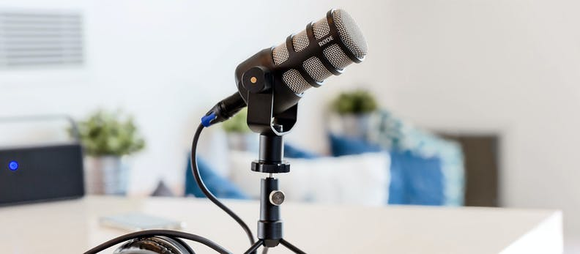

As microphones are used for different purposes, the demand for all types of microphones is quite equal in marketplaces. So, we need to choose the best one according to need. Here in this article, we are going to discuss the top 5 best-rated microphones available on amazon. Without talking further, let’s start the discussion.

**Top 5 Best Microphones:**

# HyperX QuadCast HX-MICQC-BK

# Blue Microphones Yeti

# Audio - Technica AT2020

# Audio - Technica AT2035

# SONY Electret ECM-PCV80U

# Valve microphone - WikipediaCondenser Microphone Pictures | Download Free Images on Unsplash



# HyperX QuadCast HX-MICQC-BK

# Best-rated microphone

# HyperX QuadCast HX-MICQC-BK

**¥ 16,500**

Rating: ★★★★✵ 4.5 out of 5

9630 reviews

**……………………………………………………………….**

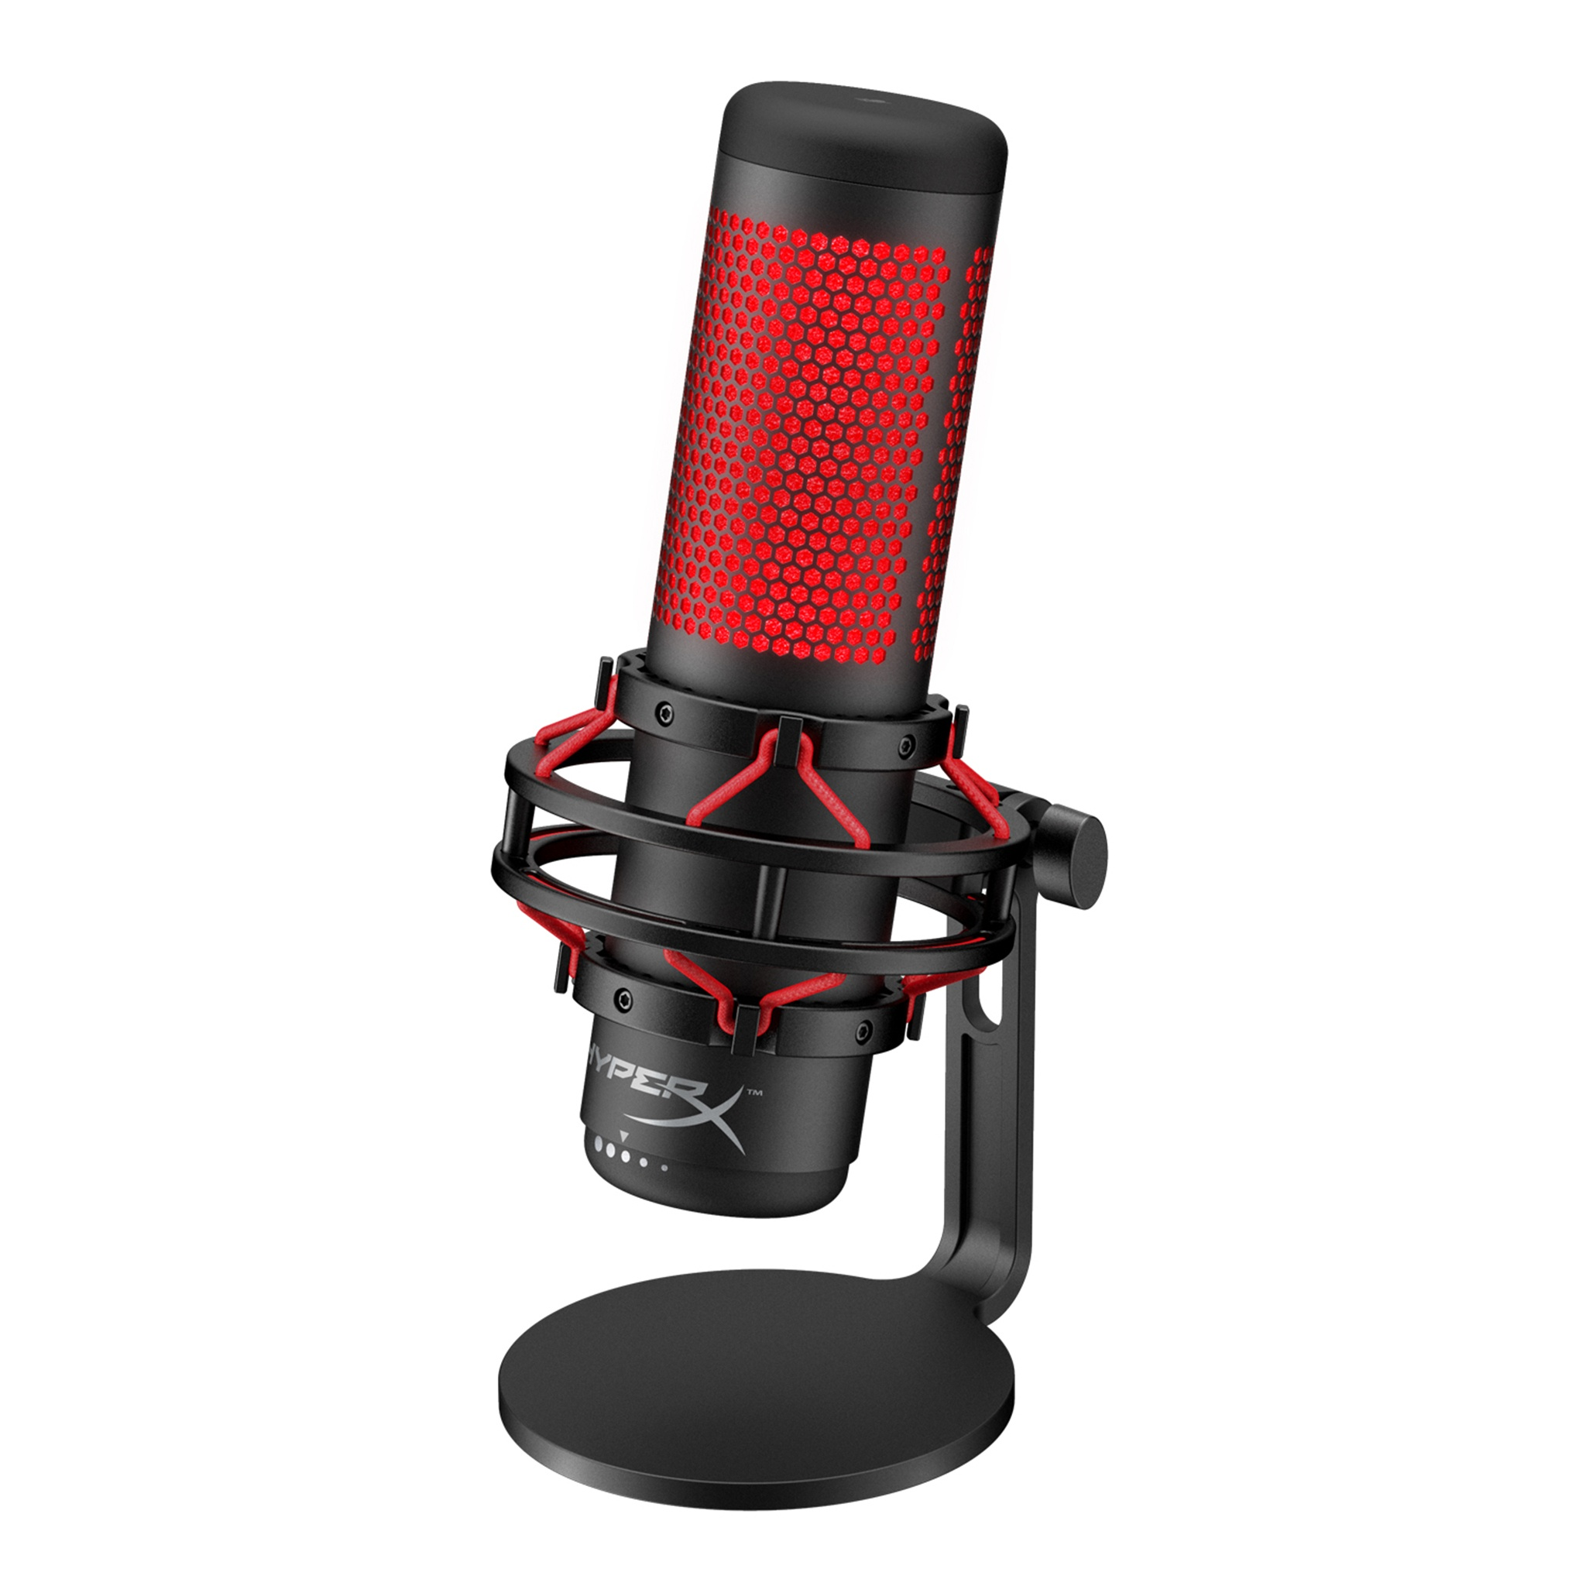

|  |  |
| --- | --- |
| **Brand** | **HyperX** |
| **Model** | **HX-MICQC-BK** |
| **Dimension** | **12.8x10.2x24.9 cm** |
| **Weight** | **725.75 gm** |
| **Voltage** | **5 volts** |
| **Frequency** | **20 Hz - 20 kHz** |
| **Noise ratio** | **90 dB** |

**Product Review**

**……………………**

Streaming online is getting much more popular in recent times. People want gaming headsets and good quality mics to become the next branding streamer. However, you won’t be able to keep your audience happy for so long with just headset mics. Keeping these things in mind, a unique brand has arrived at the marketplace; which has earned the title of one of the best gaming microphones out now. This HyperX QuadCast HX-MICQC-BK has brought a broader proposition, for those interested in streaming while they play, or in multimedia creation like YouTube content. [See more reviews.](https://www.youtube.com/watch?v=dlF4-SiuA0M)

|  |
| --- |
| [Buy it on Amazon](https://www.amazon.co.jp/-/en/HX-MICQC-BK-Standalone-Microphone-Streamers-Compatible/dp/B07NZZZ746/ref=sr_1_1?dchild=1&keywords=%E3%83%9E%E3%82%A4%E3%82%AF&qid=1618290840&sr=8-1) |

# Blue Microphones Yeti

Best quality microphone

# Blue Microphones Yeti

¥ 16,929

Rating: ★★★★✵ 4.5 out of 5

680 reviews

**…………………………………………**

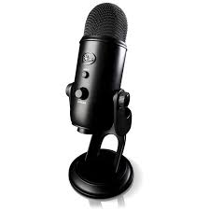

|  |  |
| --- | --- |
| **Brand** | **Blue Microphones** |
| **Style** | **Yeti** |
| **Color** | **Blackout, Silver** |
| **Frequency** | **20 Hz - 20 kHz** |
| **Dimension** | **12.5x12x29.5 cm** |
| **Weight** | **1.55 Kg** |

**Product Review**

**……………………**

This Blue Yeti microphone has been most popular in the last several years. This product has some special features which make it different from other microphones. It can change its polar pattern in 4 different types: Cardioid, Omnidirectional, Bidirectional, and Stereo. By Blue Sherpa software you can update any of the Blue Yeti USB Microphones. As it can be used in several modes, people of all sectors can use it easily. Though its price might seem a little high; but its quality and features will surely praise you. [See more reviews.](https://www.youtube.com/watch?v=AXHI-IiBL0Q)

|  |
| --- |
| [Buy it on Amazon](https://www.amazon.co.jp/-/en/Microphones-Condenser-Microphone-BM400BK-Conference/dp/B0822PMBTZ/ref=sr_1_8?dchild=1&keywords=%E3%83%9E%E3%82%A4%E3%82%AF&qid=1618290840&sr=8-8&th=1) |

# Audio - Technica Condenser Microphone AT2020

Best budget microphone

# Audio - Technica Condenser Microphone

# AT2020

**¥ 10,780**

Rating: ★★★★✵ 4.5 out of 5

890 reviews

**…………………………………………………………………………….**

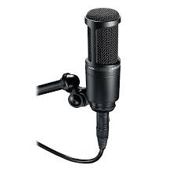

|  |  |
| --- | --- |
| **Brand** | **Audio Technica** |
| **Model** | **AT2020** |
| **Frequency** | **20 Hz - 20 kHz** |
| **Color** | **Black** |
| **Weight** | **0.35 Kg** |
| **Battery type** | **Lithium-Ion** |
| **Voltage** | **48 V** |
| **Impedance** | **100 Ohm** |

**Product Review**

**……………………**

The Audio-Technica AT2020 might be one of the best choices for those who demand good sound quality at a very affordable price. This microphone is considered a workhorse as it has so many strings to its bow. It works well as a vocal microphone as well as for recording. It is also perfect for recording acoustic guitars and other instruments. This Audio-Technica is the ideal starter microphone for any newcomer. That’s why this product is now in high demand.

[See more reviews.](https://www.youtube.com/watch?v=Jp76qV9R1Fg)

|  |
| --- |
| [Buy it on Amazon](https://www.amazon.co.jp/-/en/Audio-Technica-Condenser-Microphone-AT2020/dp/B000Y0FBY6/ref=sr_1_9?dchild=1&keywords=%E3%83%9E%E3%82%A4%E3%82%AF&qid=1618290840&sr=8-9) |

# Audio-Technica AT2035

Best quality microphone

# Audio-Technica AT2035

**¥ 16,280**

Rating: ★★★★✵ 4.5 out of 5

228 reviews

**……………………………………….**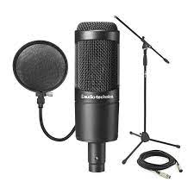

|  |  |
| --- | --- |
| **Brand** | **Audio-Technica** |
| **Model** | **AT2035** |
| **Batteries** | **1 Lithium ion** |
| **Frequency** | **20 Hz - 20kHz** |
| **Impedance** | **120 Ohm** |
| **Noise-ratio** | **80dB** |

**Product Review**

**…………………..**

The Audio-Technica AT2035 has been designed purely for home and project studios. It is easier for those who don’t want the hassle of needing extra equipment. But if you are ok with extra equipment and want to try different features; there might be many more options available for you. The AT2035 model contains a back electret design which means there’s a permanent charge held within the mic itself. That’s why its performance is admirable. [See more reviews.](https://www.youtube.com/watch?v=JA8fdCRp9_A)

|  |
| --- |
| [Buy it on Amazon](https://www.amazon.co.jp/-/en/Audio-technica-AT2035-Side-Address-Microphone/dp/B001JERO46/ref=sr_1_4?dchild=1&keywords=%E3%83%9E%E3%82%A4%E3%82%AF&qid=1618290840&sr=8-4) |

# SONY Electret Condenser Microphone ECM-PCV80U

Best budget microphone

# **SONY Electret Condenser Microphone**

# **ECM-PCV80U**

¥ 3774

Rating: ★★★★☆ 4 out of 5

2785 reviews

**……………………………………………………………………….**

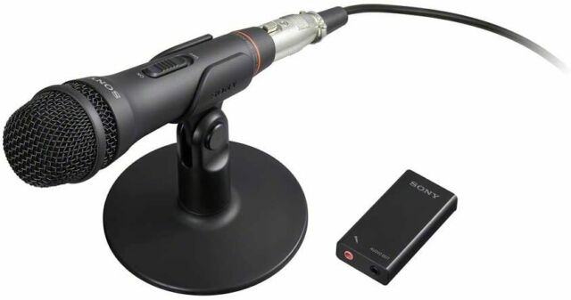

|  |  |
| --- | --- |
| **Brand** | **Sony** |
| **Model** | **ECM-PCV80U** |
| **Connector** | **USB Terminal** |
| **Power Source** | **Power Cord Type** |
| **Weight** | **0.53 Kg** |
| **Frequency** | **80 Hz - 15 kHz** |

**Product Review**

**………………..**

This **SONY** **ECM-PCV80U** model is recommended for general purpose use like audio recording, video postings on social media platforms. It features a solid die-cast body with a mic holder and a table stand which helps you to adjust with your best angel. Sony ECM-PCV80U is better than some average microphones available in the market. [See more reviews.](https://www.youtube.com/watch?v=7yUCqHcZH0U)

|  |
| --- |
| [Buy it on Amazon](https://www.amazon.co.jp/-/en/SONY-Electret-Condenser-Microphone-ECM-PCV80U/dp/B005M2HDA6/ref=sr_1_5?dchild=1&keywords=%E3%83%9E%E3%82%A4%E3%82%AF&qid=1618290840&sr=8-5) |